**CS691 - Computer Science, Fall 2020**

**Project Initiation Document**

Project: MLDB (Movie Library Database)

Project Manager: Rucha Madan

Start Date: 08/25/2020

Completion Date:

Table of Contents

Document Purpose 5

Background to the Proposed Work 5

Vision 5

Project Objectives 6

Project Scope 6

Business Case 7

Assumptions 8

Constraints 9

Risk Management Strategy 10

Deliverables 12

Stakeholders 13

Project Team 14

Project Plan 16

Project Controls 17

Communication Plan 17

Document Details

|  |  |  |  |
| --- | --- | --- | --- |
| Version | Modifications | Author | Date |
| 1.0 | Initial PID Document | Rucha Madan | 3/9/2020 |
| 1.1 | Adjustments to initial PID Document | Rucha Madan | 8/9/2020 |
|  |  |  |  |
|  |  |  |  |

Approvals

This document requires the following approvals:

|  |  |  |  |  |
| --- | --- | --- | --- | --- |
| Name | Role | Signature | Date | Version |
| Rucha Madan | Project Manager |  |  |  |
| Michael Lee | Product Owner |  |  |  |
| Swapnil Lonkar | Lead Business Analyst |  |  |  |
| Radiy Madveev | Lead Developer |  |  |  |
| Rodrigo Martins | DBA |  |  |  |
| Suraj Kolari | Lead QA/Tester |  |  |  |
| Yuri Chernak | Professor |  |  |  |

Distribution

This document has been distributed to:

|  |  |  |  |
| --- | --- | --- | --- |
| Name | Role | Date of Issue | Version |
| Rucha Madan | Project Manager |  |  |
| Michael Lee | Product Owner |  |  |
| Swapnil Lonkar | Lead Business Analyst |  |  |
| Radiy Madveev | Lead Developer |  |  |
| Rodrigo Martins | DBA |  |  |
| Suraj Kolari | Lead QA/Tester |  |  |

# Document Purpose

The purpose of the Project Initiation Document is to provide details about the Movie Library Database and its features. The website's main objective is to concentrate a wide range of movie information in one platform and intermediate ticket sales between users and providers obtaining profit through a service fee. The project aims to improve and simplify cinephiles’ access to movie information available throughout the web.

This project involves a cooperation between Project Manager, Product Owner, Lead Business Analyst, Lead Developer, DBA and Lead QA/Tester, so it will be organized, structured and implemented according to each team member’s skills.

Version control will be used for project management in order to facilitate communication between team members. Any changes should be subjected to all team member’s approval.

# Background to the Proposed Work

It is probably one of the most fascinating phenomena of the 21st century, the amount of time every human being spends in front of the screen. Latest research shows that a large portion of the time spent in front of the screens is apportioned to the consumption of cinematic products (TV shows, movies, news feeds, podcasts etc.). This evidently yields an opportunity for market capitalization in the specific niche of gathering and storing descriptive information about aforementioned products.

MLDB will be the leading online place to find latest developments in your favorite show. A visitor will be able to learn about cast members, production process. Movie Library Database will be one of the largest aggregators of all cinematic information that can be found online or in print. We see our end product as one stop, easily accessible and fully comprehensive all things cinema web resource for all the cinefiles of the world.

This niche isn't well developed yet and we see the absence of such a product as an opportunity remissed.

# Vision

To provide a concise workable website/application for users to research movies, see reviews, and trailers. Some features that might be included would be whenever a review hits 40% a small icon will show. Also, everytime a user makes a review they will receive a star that leads to free movie tickets.

# 

# Project Objectives

Providing cinematographic information on motion pictures current and past. Our web application will serve as the leading online aggregator of all things cinema. It would include movies’ cast, personal biographies, plot summaries, ratings, fan and critics’ reviews. In principle, the platform will unite all the cinephiles around the globe. Providing a niche specific online outlet that will facilitate discussions and interactions amongst professional movie makers, online streamers, movie goers.

**Goal**: Increase sales.

Objectives: Search engine optimization, well-organized content, user-friendly site, effective calls to action, increase conversion rate.

**Goal**: Becoming an authoritative resource.

Objectives: Providing quality content on your website, regularly adding new information, establishing trust, marketing your site on other websites and social media.

**Goal**: Improve interaction with existing and potential customers.

Objectives: Email marketing lists, online support (live chat), webinars, and content designed to give your visitor a reason to come back.

**Goal**: Build your brand.

Objectives: Active social media program, promotions, reputation management.

The ultimate goal or objective would be to grow the company’s bottom line and increase profitability.

# Project Scope

* The project will deliver a website with the help of which users can search movies and can see it’s cast, personal biographies, plot summaries, ratings, fan and critics’ reviews.
* Following functions will be implemented –
  + Users will be able to check the rating of movie ,TV shows.
  + Users will be able to grab synopses, runtime details, content advisory guide of a movie or a tv program.
  + Users can browse the cast list of a movie, TV show.
  + Users will be redirected to a booking site if they want to book a movie ticket.
* The project has potential to impact all the cinephiles around the world who are curious about movies,TV shows. MLDB will help the users save money by helping them to choose a movie which is ‘bang for a buck’.

# 

# Business Case

|  |  |
| --- | --- |
| **Application Name** | MLDB (Movie Library Database) |
| **Type of business model** | Ad revenue, Brokerage |
| **Target audience of users** | Cinephiles |
| **Value proposition** | Providing cinematographic information on motion pictures current and past |
| **How the system is used** | Web Application  Our web application will serve as the leading online aggregator of all things cinema. It would include movies’ cast, personal biographies, plot summaries, ratings, fan and critics’ reviews. Here are some perks the customers would enjoy visiting our website:   1. Checking ratings for movies and TV shows. 2. Grabbing synopses and runtime details before deciding to watch something. 3. Browsing cast list because you recognize a face but don't quite remember from where. 4. Content Advisory Guide. 5. Ticket selling.   In principle, the platform will unite all the cinephiles around the globe. Providing a niche specific online outlet that will facilitate discussions and interactions amongst professional movie makers, online streamers, movie goers. |
| **Revenue generation** | Advertisement, Ticket sales |
| **Partners/Suppliers**  **(Stakeholders)** | Movie Theatres, Digital Marketing Companies, Topical Database Companies, Production Companies, Film Studios |
| **Groups of internal stakeholders, users** | Content Managers, Web Developers, Software Engineers, Writing Editor, Project Manager, Product Owner, Quality Assurance |
| **Expected Benefits** | One hub that stores information related to films, television programs, home videos, online streaming content |
| **Known Prototypes** | TMDB:  <https://www.themoviedb.org/>  Rotten Tomatoes:  <https://www.rottentomatoes.com/>  IMDB:  <https://www.imdb.com/> |

# Assumptions

|  |  |  |  |
| --- | --- | --- | --- |
| Assumption | Validated by | Status | Comments |
| Project Budget | All members | In process | Initial budget for our product is set in the range of $150-$200 |
| Meetings | Project manager | Finalized | The team decided to gather at least 2 times a week to set goals and report on the timeline of the project’s delivery |
| Project resources | Product Owner | In process | PM will be closely monitoring and reporting to the PO that all the needed resources are in place |
| Team composition | All members | Finalized | The composition and position of each team member will stay the same for the entire life of the project. Each member confirmed his/her intention to take Project II in the next semester |

We strongly believe that currently we are in possession of all the needed resources to deliver a comprehensive product in the given period of time. All team members are in sync with technology used to deliver the final product (HTML, JavaScript, DB systems, used IDE, OS etc.)

# Constraints

Certain aspects which are needed to be taken into consideration during the delivery of the project, but are not limited to, are as follows:

* A responsive web page, which supports all browsers.
* API access limitations.
* Time is rather the main part. Project planning must be done properly, which includes the meeting time of group members and the completion time of the project.

# Risk Management Strategy

The risk management part is an important part in the planning of any project. It is used as a plan to prepare for the event of any foreseen and unforeseen risks.

RMS Diagram

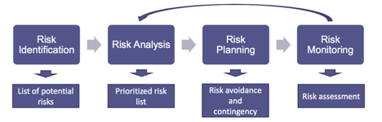

* Risk Identification is the process in which the group lists and identifies potential risks that may occur during the project.
* Risk Analysis is taking that list of risks and prioritizing them in order to determine which risks are more important and detrimental to the project than others.
* Risk Planning is creating and affecting a plan of attack if and when a risk occurs. This is probably the most important step due to how well the risk would be handled and what effect it might be on the project.
* Risk monitoring is a continuous operation in which the group keeps an eye on all moving parts of a project and sees when a risk is probable of happening in real time.

The main strategies that will be used during this project is as follows:

|  |  |
| --- | --- |
| Avoid Risk | A risk that might come up that is so serious that it is needed to be disbanded and avoid the cause altogether. |
| Control/Mitigate Risk | A risk whose activity is a required and important aspect of the project and must be able to be replaced in case of something going awry. |
| Accept Risk | Risk that the group deems that is probable and accepting the consequences (ex. Sunk costs) and is expected to happen throughout the life of the project and this must be budgeted for. |
| Transfer Risk | If risk can not be mitigated, the group must be willing to seek out a third party who will be able to handle the risk at a cost. |

This is a list of the possible risks that may come up over the course of the project:

|  |  |  |  |
| --- | --- | --- | --- |
| Risk | Probability | Impact | Mitigation Method |
| Loss of data | Low | High | Having scheduled data backups and redundancy backups planned for the future. |
| Budget overhead | Medium | Medium | The key preventive action we can take is to stay realistic. Identify your core priorities – whether it’s time, cost or quality. |
| API unavailability | Low | Medium | Having multiple API sources |
| Exceeding timeframes | Medium | Medium | To avoid missing your project deadlines, remain in constant communication with your web developers. Take into account that debugging takes 50% of software development time. |
| Stakeholder action delays project. | Low | High | Identify stakeholders, analyze power and influence and create a stakeholder engagement plan. Project Board to authorize the plan. Revisit the plan at regular intervals to check all stakeholders are managed. |
| Data Security Breach | Medium | High | Adhere to all common security practices. Adopt OWASP top 10 documents to minimize risk. |

# 

# Deliverables

The deliverables of the project for phase 1 are:

|  |  |  |
| --- | --- | --- |
| **No** | **Artifact Name** | **Responsible Party** |
| **1** | Project Plan | PM |
| **2** | PID document | PM |
| **3** | BRM Diagram | Product Owner |
| **4** | Context Diagram | Lead BA |
| **5** | Architecture Diagrams (2) | Lead Dev/DBA |
| **6** | User Requirements | Product Owner |
| **7** | RCT (includes func. decomp., supplementary reqs) | Lead BA |
| **8** | Use-Case Diagram (UML) | Lead BA |
| **9** | Activity Diagram (UML) | Lead BA |
| **10** | Data-flow Diagram | Lead BA |
| **11** | Functional Requirements (user stories) | Lead BA |
| **12** | Class Diagram (UML) | Lead Dev |
| **13** | Sequence Diagram (UML) | Lead Dev |
| **14** | ER Diagrams (conceptual, logical) | DBA |
| **15** | Table Specs | DBA |
| **16** | Source code sample (part of Application Demo) | Lead Dev |
| **17** | Test Plan document | Lead QA |
| **18** | Application Demo | All |

# Stakeholders

|  |  |
| --- | --- |
| Stakeholder | Interest |
| Movie Theatres | Increase ticket sale. |
| Digital Marketing Companies | Higher reach of their targeted advertisement. |
| Topical Database Companies | Data collection for third party sale. |
| Production Companies/Film Studios | Promotion of their films. |
| Internal Stakeholders | **Interest** |
| Content manager | To develop a consistent brand identity for a company and establish its online presence. |
| Web Developer | Modifying and updating websites according to a company or client's specifications. Ensuring that websites are visually attractive and user-friendly. |
| Writing Editor | Suggesting stories and generating headline ideas in alignment with targeted audience's preferences. |
| Project Manager | Project management responsibilities include the coordination and completion of projects on time within budget and within scope. |
| Quality assurance | Reviewing quality specifications and technical design documents to provide timely and meaningful feedback.Creating detailed, comprehensive and well-structured test plans and test cases. |

# 

# Project Team

The project team includes the following roles:

* Project Manager – Rucha Madan
* Product Owner – Michael Lee
* Lead Business Analyst – Swapnil Lonkar
* Lead Developer – Radiy Matveev
* DBA – Rodrigo Martins
* Lead QA/Tester– Suraj Kolari

The following is the organizational chart which displays the role of each project team member responsible for different tasks and deliverables.

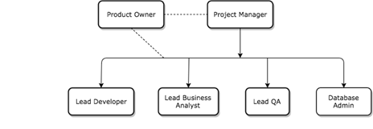

The roles and responsibilities of the team roles are shown in the RACI Table below:

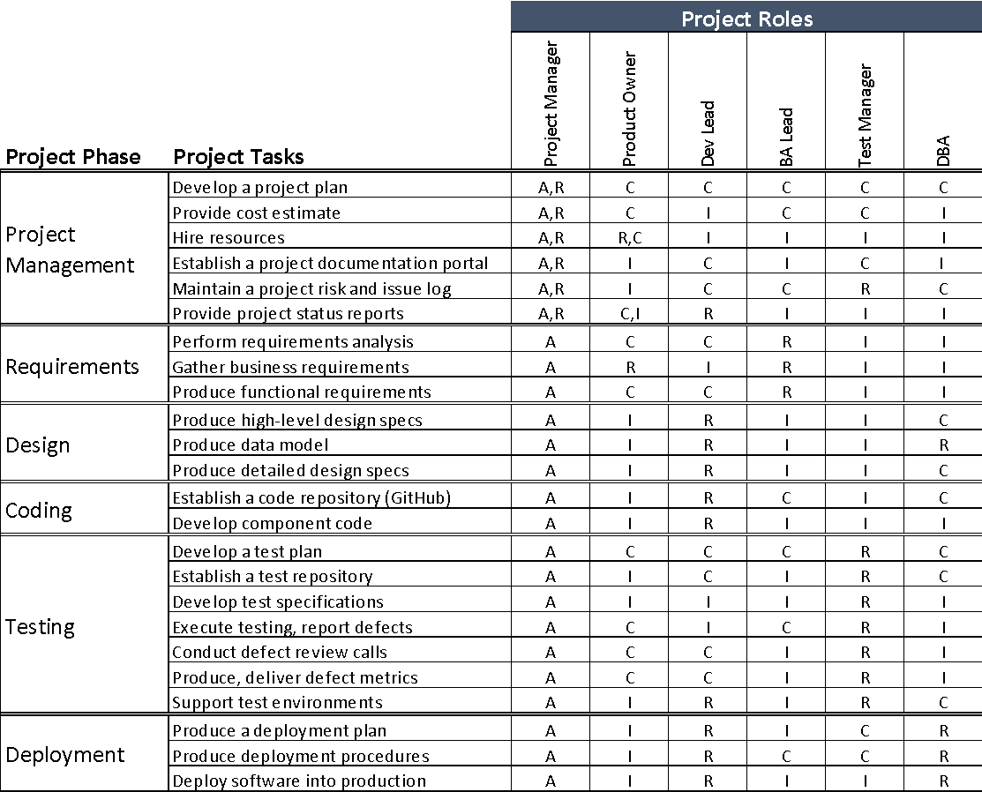

# Project Plan

This section will include a summary of the project plan, including a schedule of activities and resource requirements. Indicate, the team will follow the Agile development methodology.



Milestones:

MS1: Initial Project Plan (9/10/2020)

MS2: Requirements Completed

MS3: Design Completed

MS4: Coding Completed

MS5: Testing Completed

MS6: Project Presentation

# Project Controls

* The team will meet weekly on Thursdays to monitor progress and work on issues. The meeting will be hosted by the project manager on Zoom. Every team member’s presence is expected at the meeting, and if needed additional meetings will take place.
* The Project Manager will report weekly meeting minutes to Professor Chernak and if any team member is absent for a meeting he will receive the meeting report from the project manager.
* The primary means for communicating with stakeholders is Email exchange. Another communication channel will be Slack. Whatsapp will be used for informal discussion between team members.
* Google Drive will be used to store and make files available within the team, and to store the official documentation, and a Git repository will be created to manage the source code

# Communication Plan

|  |  |  |  |
| --- | --- | --- | --- |
| Stakeholder | Frequency | Type | Purpose |
| Content Manager | At key stages of the implementation of the project | Live meeting / Conference call / Video conference | Organize the content that will be available in the web application |
| Web Developer / DBA | At development stage | Live meeting / Conference call / Video conference | Organize ideas and features of the project and the design of the application |
| Quality Assurance / Tester | At the final stage | Live meeting / Conference call / Video conference | Approve the project implementation |
| Project Manager / Product Owner | At key stages of the implementation and when changes are made in the project | Live meeting / Conference call / Video conference | Review project status and discuss issues or changes in the project |